Case 5 (in Oceania)-Asia-China-Sui-Horse-Terra cotta-
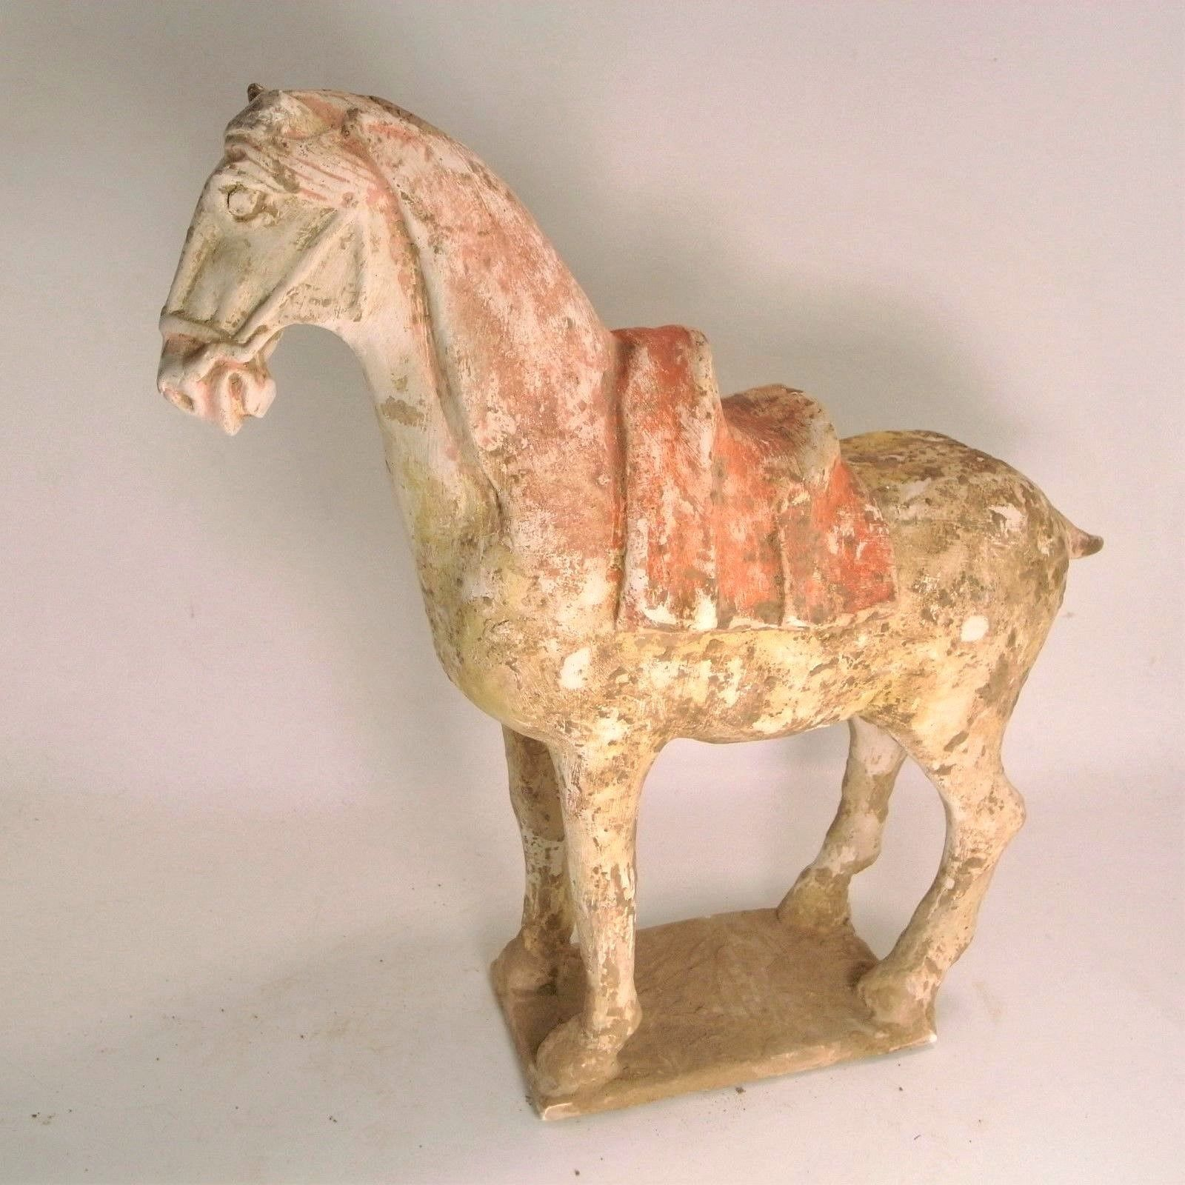
An ancient Chinese Sui Dynasty painted terracotta horse, dating to 600 AD.
Shown about to rear backwards, as if struggling against its reigns, this horse is a picture of vibrant energy and virility. Wearing a finely modelled saddle, with stirrups, skirt and pommel all shown. The facial expression is intense, with the animal biting down on its bit, the eyes wide and mane swept across the forehead, the head faces downwards, typical of the Sui style.
This is one of the finest examples of a Sui Dynasty horse currently on the market. Less well known than its successor, the Tang, the short lived Sui Dynasty laid the economic and artistic foundations for what came after. This stunning horse is a fine example of the increased naturalism that would come to define Chinese ming-qi styles in the coming centuries.

Height: 18 1/2 inches
Length:
Width:

Condition: Minor restorations throughout. With Oxford Authentication thermoluminescence test and Art Loss Register certificate.

Provenance: Ex. Belgian private collection, acquired 1980’s
Ancient Chinese Terracotta Sui Dynasty Horse - 600 AD
Follow this seller
Visit store:
Antiquities Sale
See other items
Top of Form
Item condition:
--
Price:
US $29,000.00

Seller information
| Add to watch list
artancientltd (9067 )
99.9% Positive feedback

